East Midland Baptist Association

ANNUAL REVIEW 2022-2023

A review of our life together as an Association
of Baptist Churches in the East Midlands

Presented to the AGM on 24 June 2023

East Midland Baptist Association
Registered Charity Number: 1094457 Registered Company Number: 4302466
Registered Office: EMBA Office, c/o West Bridgford Baptist Church, Melton Road,
West Bridgford, Nottingham NG2 7NF
Contents

EMBA Staff Team 3
EMBA Board of Directors 3
Report of the EMBA Directors 4
East Midland Baptist Trust Company (EMBTC) 6
EMBTC Small Building Project Grants 7
Rooted 7
Re:imagine 8
EMBA Children, Young People and Families (CYF) 8
EMBA Ministry Recognition Committee (MRC) 9
Grants Group 9
Safeguarding 10
EMBA Associates for Training: Revd Elaine Burrows and Revd Nick Swanson 11
Gracious Conversations Series 12
EMBA Ministers’ Conference 12
Refresh (EMBA women conference) 13
EMBA Retired Baptist Ministers’ Network (RBMN) 13
BUEN: Baptist Union Environment Network 15
Welcome to new EMBA ministers 16
Welcome to new churches 16
Ministerial Recognition 16
Finance review 17
Making donations 17
EMBA Working Groups 18
Contacting the Association Team 19

EMBA Staff Team

Administration
Mrs Becky Nicholls – Admin Lead and PA to Regional Team Leader
Mrs Gill McNab – Admin Assistant

Regional Ministers
Revd Mark Clay – Regional Team Leader (RTL)
Revd Dr Nick Ashton
Revd Mike Fegredo

EMBA Board of Directors

EX-OFFICIO MEMBERS
Regional Team Leader: | Revd Mark Clay
Treasurer: | Mr Andy Smallridge | Melton Mowbray BC, Leics
ELECTED MEMBERS
Moderator: | Revd David Harvey | Belper BC, Derbys
 | Revd Hannah Colk | Robert Hall Memorial BC, Leics
 | Mrs Ellie Cox | Oadby BC, Leics
 | Revd Sam Hackett | Ruddington BC, Notts
 | Revd Martin Hills | Oundle BC, Peterborough
 | Revd Matt Jones | Westdale Lane BC, Notts
 | Mrs Kay McManus | New Day BC, Morton, Lincs
 | VACANCY
CO-OPTED MEMBERS
 | NONE
NON-VOTING MEMBER
Company Secretary: | Mrs Becky Nicholls

At the 2023 AGM there will be two vacancies on the EMBA board of Directors.

Report of the EMBA Directors

Objectives and Activities
The objects of this charitable company are the advancement of the Christian faith, particularly across the East Midlands and especially by the means of and in accordance with the principles of the Baptist denomination as set out for the time being in the Declaration of Principle of the Baptist Union of Great Britain (BUGB).
The charitable company exists as a network of churches seeking to serve God’s kingdom, led by the Holy Spirit, enabling all to do everything possible to fulfil God's apostolic mission and ministry within the communities in which they are placed. The charitable company believe that the local church is the primary way in which God’s apostolic mission is fulfilled and as such, healthy churches are crucial to seeing God at work across the region. The trustees of the charitable company are committed to growing healthy churches through inspiring, equipping, pioneering, caring and partnering. These five priorities guide the work of the charitable company.
The principle activities of the charitable company are the employment of a Regional Ministry and administrative staff team and the organisation of a number of volunteers, working in groups or individually, to offer support and guidance, training and financial resources to advance the Christian faith in a way which benefits Baptist churches and the communities they serve.
The charitable company is part of the family of Baptist organisations serving the needs of many of the Baptist churches in Great Britain, working particularly closely with the Baptist Union of Great Britain and BMS World Mission.
Achievements and Performance
At the AGM held at Queensberry BC on 25 June 2022, we paid tribute to John Brewster and David Howe both standing down as Directors having served the Association for the maximum allowed three consecutive terms. Mrs Kay McManus was elected following a period as a co-opted Director, and I was re-elected for my third and final term. Most of our meetings are now held in person. Revd Sam Hackett will be leaving us this July to take up a post as a Chaplain at Bristol University.
At the AGM, the gathered churches approved the appointment of Andy Smallridge as the new Association Treasurer. Thanks were expressed to Tim Jackson standing down after many years as Association Treasurer. Tim will continue to act as Treasurer to the East Midland Baptist Trust Company (EMBTC). It was also good to welcome several new ministers to the Association and to give the right hand of fellowship to ministers to celebrate their accreditation.

Those present at the AGM were informed that proposed changes to the Articles of Association would be formally presented to the 2023 AGM. The key points were outlined, and questions invited. Delegates were informed that there would be a period of consultation with all the churches including an on-line Q&A session. This consultation was completed during January 2023. The Directors have considered the results of consultation and are bringing the revised Articles to this AGM for adoption.
Notwithstanding the increased use of digital communications and decision making, the Association recognises the vital importance of creating opportunities for churches to gather for worship, to hear inspiring speakers, and to share experiences and fellowship. This will be in addition to the many gatherings associated with training for ministers and church leaders.
The Strategic Review of the Association continues with detailed consideration of how best to support churches and pioneers and chaplains in missional thinking and activities, balancing the many things we would like to do against the reality of diminishing giving to Home Mission nationally, which affects the amount of income the Association receives. The Directors and Staff Team continue to look for innovative ways to engage with and draw on the skills and experience of Regional Associates, ministers, church leaders, and the many retired ministers in our region. We are grateful for all the work done on a voluntary basis by so many. We are always keen to hear from those who have a passion to see God’s Kingdom grow and have some skills and time available. Please contact any of the Directors or Regional Ministers.
The Directors express sincere thanks to the Staff Team. Mark Clay, Mike Fegredo and Nick Ashton do a fantastic job as Regional Ministers under a lot of pressure to meet the many challenges of their roles. The Staff Team continues to pursue improvements in communications and back-office systems. It has been good to have Gill McNab supporting Becky in the Admin Team, Sarah Fegredo giving valuable consultancy support on Office 365 and ChurchSuite, Hannah Fleming-Hill acting as Communications Lead, and Irene doing our bookkeeping and supporting the Treasurers.
The Directors encourage you to pray for the Staff Team on a regular basis.
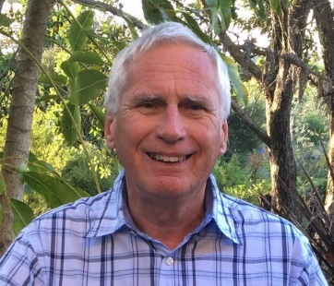

Revd David Harvey
Moderator of the EMBA board of Directors

East Midland Baptist Trust Company (EMBTC)
Purpose Statement
The East Midland Baptist Trust Company (EMBTC) primarily acts as ‘Custodian Trustee’ for many EMBA churches. In addition, it has responsibility for advising congregations on property related matters; the maintenance of burial grounds arising from ‘closed’ churches; and the consideration of Small Building Project Grant (SBPG) applications from EMBA churches.
Achievements and Performance
The last year has been relatively uneventful for the EMBTC. The unchanged Board has met regularly both virtually and in person. All matters have been conducted expeditiously and efficiently. We are grateful to our own Becky Nicholls and Sally Spicer and Tim Chowns of the Baptist Union Corporation for their support.

The Board has continued to support the churches of the Association with regard to property and legal matters related to Trust deeds and to applications for BUC loans, as well as assisting those churches which are closing to resolve legal and financial matters, a sad but necessary task. We are grateful to the BUC staff at Didcot for their unstinting support but we were sad to say farewell to the CEO, Richard Wilson, as he moves to another mission. Listed church buildings present challenges from time to time and we have been well supported by the BU Listed Buildings team.

Some Associations have passed all their trustee work to the BUC while others, including ourselves, maintain a Trust Company although we contract with the BUC to undertake the practical and legal work. As EMBTC Moderator, I sit on the BUC Board and also participate in meetings with other Trust company secretaries. Both these activities are invaluable in providing early warning on changes in the law relevant to our churches.

There are a number of issues developing around Charity law, rental property, equality and gender matters as well as the continuing problems associated with Social and Heritage Asset listings. The Board intends to keep abreast of all these issues and bring you notification at an early stage.

The eligibility rules of the small building project grants scheme have been revised to focus on smaller projects rather than supplements to larger schemes. Gary Anderson is always happy for churches considering an application to contact him for advice before making a submission.
The Board continues a review of our procedures and the scope of what we undertake as a Trust body. We continue to see a small number of churches take their property out of Trust with EMBTC as they have become CIOs and expect that to increase in the future.

The EMBTC remains on a firm financial foundation and we look forward to supporting the churches in 2023-4. Our prayer is that the resources we hold and the expertise available may be used by the churches of the East Midlands to grow the Kingdom in new and imaginative ways to God’s glory.
Dr Chris Hanning (EMBTC Moderator)

EMBTC Small Building Project Grants
The East Midland Baptist Trust Company (EMBTC) established the Small Building Project Grant fund to support EMBA churches in the maintenance, renewal and development of their church buildings.
Over the past year, EMBTC have awarded five Small Building Project Grants to assist with the following projects:
- Buckminster Road Baptist Church, Leicester – Refurbishment of three rooms for community use.

- Central Baptist Church, Leicester – Garden project.

- Chesterfield Baptist Church, Derbyshire – lift repair, additional car parking and floor levelling.

- Mountsorrel Baptist Church, Leicestershire – new upstairs toilet facilities.

- Swanwick Baptist Church, Derbyshire – re-roofing, replacing entrance door, insulation and damp proofing.

Rooted
Rooted is the EMBA’s commitment to equip ministers and leaders for contemporary ministry and to help churches engage in mission and ministry in our ever-changing world. Themed days (usually three) are held each year that provide an opportunity to reflect theologically and practically on a particular aspect of ministry. The day is broadly aimed at either Ministers and Pastors (Rooted for Ministers), wider church leadership teams, including ministers and pastors (Rooted for Leaders), or open to everyone (Rooted for Everyone). We aim to make the days as practical as possible with subjects covered that stimulate our thinking in mission and ministry.
Sadly in 2022, two of the days (May and November) had to be cancelled as the numbers did not make the events viable. In early March 2023, we held our first Rooted for 2023. Corin Pilling, UK Director for Sanctuary Mental Health Ministries, UK, joined us and led a day for ministers on ministerial sustainability and well-being.
All sessions are delivered free of charge to EMBA churches, although donations are always welcome to offset costs. We are always happy to receive suggestions for topics or themes to be explored.

Re:imagine

Our second cohort of Re:imagine started in March 2022, and we have just held the third of four sessions encouraging five church leadership teams on their missional journey.
Re:imagine takes participating churches through a two-year learning and development process and encourages leadership teams to reflect on areas of culture, leadership, discipleship and mission so that they are better equipped to engage with the communities they are part of and be kingdom focused churches.
re:imagine
There is one more session for this Re:imagine cohort that takes place in October 2023. We will then be looking to see if a third cohort will be viable starting at some point in 2024! So, if your church would be interested in joining, or you would simply like to find out a bit more information about what is involved, please speak to your regional minister, contact the EMBA Office or visit the EMBA website.

EMBA Children, Young People and Families (CYF)
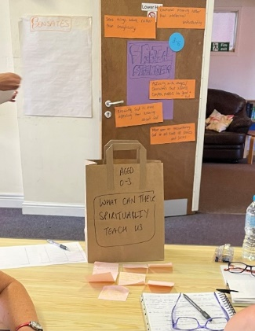
The last year has seen CYF activity in a number of areas:
The Spiritual Child Training day in Grantham – July 2022
This was a day of training run by Revd Clare Hooper of Bristol Baptist College in partnership with Grantham Baptist Church. We were encouraged to think about the spiritual lives of the children and young people we work with, and not only how we can support them, but what we can learn from children. More than fifteen people attended.

Representing EMBA at the National CYF Round Table in November 2022, and March 2023.

- November 2022 – The Good Childhood Report 2022. Published annually by the Children’s Society this report highlights the challenges to children’s wellbeing. The 2022 report headline was “Our Good Childhood report 2022 has revealed a deeply concerning continuing decline in children’s wellbeing. We talked about what that might mean for the work happening in our churches in the light of Matt 5:1-12, noting that “The orientation in the Beatitudes is towards those who don’t have power.” We noted that “The church really is well-placed to continue to support children and young people, not least by being a safe place where they can be themselves and to have fun!” https://www.childrenssociety.org.uk/information/professionals/resources/good-childhood-report-2022

- March 2023 – Reflecting with Stephen Elmes (Minister at Bookham Baptist Church) about the current consultation on human sexuality and how we can work with young people and children in this area. We noted a range of thoughts from young people on this issue and pondered how we can ensure their voices are heard in church and that young people struggling in this area are loved and support by their church families.

As well as the work described above, I am also regularly contacted by individual churches seeking advice about aspects of their ministry to children and young people including:
- Challenges of recruiting youth and children’s workers
- Approaches to children’s and youth work in post-COVID times
- Queries about best practice

Revd Sarah Fegredo, EMBA CYF Associate

EMBA Ministry Recognition Committee (MRC)
The Ministry Recognition Committee primarily works with those who are exploring a call to ministry across the EMBA.
Since the last AGM, the EMBA have held three MRC’s and all three candidates were commended to the Baptist Union of Great Britain.
In addition, we also have two candidates who are exploring accredited ministry and preparing to go through the ministerial recognition process. Please do pray for them that they would know God’s leading at this time.
MRC is comprised of representatives from the regional team, EMBA ministers, and others who have been appointed by our churches. We are grateful for the work and time that they give to this group.

Grants Group
Whilst we recognise that the last few years have been financially challenging for many of our churches, we continue to give thanks to God for his generous provision and the faithful giving of many of our EMBA churches to Home Mission. Your generous giving as churches and individuals continues to support the ongoing work of our Baptist Family nationally, regionally and locally. In 2023, EMBA are continuing to fund three Mission Grants and two Pioneer Mission Grants.
Two years ago, a new ‘Minister in Training’ (MIT) training grant was created to provide funding for those in EMBA churches who are preparing to train for Accredited Baptist Ministry, regardless of specialism. EMBA are delighted to now currently be supporting two EMBA ministers-in-training with an MITTG grant.
Our thanks go to all members of the EMBA Grants Group who give of their time to review a considerable amount of paperwork for each and every grant application submitted and carefully discern the grant to be awarded. The Regional Team are appreciative of the time commitment given and for the insights and reflections of the wider group. We especially want to thank both Revd Ellie Ake and Revd Sam Hackett for their contribution and service on the Grants Group as they move to new ministries outside of the EMBA. Please pray for the Team as they seek new group members.
Our sincere thanks also go to Mr Norman Lazonby who has faithfully served the Grants Group for many years, reviewing the accounts and finances of all applications from behind the scenes, or rather from bonnie Scotland! As Norman steps down from this role, we are grateful to Andy Smallridge (EMBA Treasurer) who has agreed to undertake the financial review of applications going forward. Further thanks are expressed to Revd Elaine Burrows and Revd Tony Haley who have acted as Home Mission visitors for a number of different churches over the years.
In recent months, the Regional Team have undertaken a review of the mission grant and pioneer mission grant criteria, process and requirements. The outcome of the review has been the creation of a new Grant; the Mission Partnership Grant available to help a Baptist Church, pioneering ministry or ecumenical partnership including Baptists, to engage effectively in mission by supporting a minister, minister in training, or other worker. The main focus for this person will be to lead the church/pioneer ministry forward in mission. At the heart of the Mission Partnership Grant (MPaG) is a more active approach involving genuine partnership between each grant recipient and the EMBA, mainly expressed through a Mission Accompanier (MA) who will journey with the ministry throughout the grant period. The grant aims to encourage and support a ministry to become thoroughly missional in nature, to foster accountability and also increase the likelihood of long term financial sustainability.
If as a church you are considering a new mission opportunity but finance is an issue, we would strongly encourage you to take a look at the different grants available on the EMBA website or talk to your Regional Minister.

Safeguarding
March 2022 saw a return to in-person church trainings following a year of online training in response to the Covid restrictions. As expected, the demand for training was incredibly high with a record total of 60 trainings being delivered during 2022 enabling over 1,200 leaders and church workers to be trained across our region!
As an Association we continue to be supported by a small but incredibly gifted team of safeguarding trainers without whom we simply could not deliver the volume of trainings we did last year and continue to do so in 2023. A massive thank you to our EMBA safeguarding team – you are all amazing!
Over the last twelve months we are delighted to have welcomed two new trainers to the team, Mrs Sarah Jones (Level 2 Trainer) and Revd Paul Muir (Level 2 and 3 Trainer) and Revd Sarah Fegredo who was already a Level 2 Trainer, undertook the additional training and is now a Level 3 trained trainer too. We are so grateful to Sarah, Paul and Sarah for being willing to give of their time and share their gifts and skills to support the work of the Association. Please continue to uphold our Safeguarding Team in your prayers. Please also pray for Alan Davies and Helen Parker, our EMBA Safeguarding Advisers who manage a significant caseload for the Association and give many hours offering support and advice to churches dealing with safeguarding concerns.
We are also very grateful to those in our churches who have taken on the role of Designated Person for Safeguarding (DPS). We recognise that the role bears significant responsibility and in response to training feedback we are delighted to have the National Safeguarding Team coming to the Association in July to lead a training day specifically for our DPS’s. Our shared hope for the day is that our DPS’s will feel supported and encouraged and more equipped in their role. For more information and to book your place please click here.
To assist with the ongoing administration of Safeguarding, Gill McNab (EMBA Administrative Assistant) is now supporting Becky Nicholls with the training administration. Furthermore, as and from May, churches will be able to book and pay for safeguarding trainings online via the EMBA website creating a quicker and more efficient administrative process for everyone. Further information about safeguarding trainings and resources can be found in the safeguarding section on the EMBA website.
We are always looking to increase our pool of EMBA ‘Trained Trainers’, especially people with professional experience in safeguarding. If you would be interested in serving the Association in this way, please contact Becky Nicholls (EMBA Admin Lead).

EMBA Associates for Training: Revd Elaine Burrows and Revd Nick Swanson
Nick and Elaine continue to serve the EMBA as Associate Trainers, working alongside the Regional Ministers in delivering training across the region.
This past year Elaine has delivered a bespoke course for one of our Association Churches as they moved into a Pastoral Vacancy. This incorporated Leadership Training for the Deacons and training for the wider congregation, ‘Preparing for Fruitfulness in a Pastoral Vacancy’ covering topics of transition and change, being Church and developing leaders.
As part of the EMBA’s ‘Gracious Conversations Series’ held in March / April both Elaine and Nick led two of the training sessions – ‘Facilitating Fruitful Conversation’ and ‘Church Conversations - practical models’.
Going forward there are plans to deliver the CPAS Growing Leaders Course, which aims to help develop emerging and existing leaders. This course focuses on the characteristics and skills of Christian leadership and combines teaching, mentoring and practical application.
There is also the potential to deliver the popular Pastoral Care course again. This has been revised to reflect the significant impact of the Pandemic on pastoral care, along with an additional session on Mental Health.
Please get in touch with Nick and Elaine to enquire about training courses or to discuss any specific training needs you have.

Gracious Conversations Series
During the past year the EMBA has run a number of training courses aiming to educate, train, equip and inspire our churches. Significantly in the spring we ran a series of courses entitled Gracious Conversations. This series of three events was provided to help our churches and ministers to think through the issues of human sexuality in a biblical, theological, missiological and pastoral way and was prompted by the BU consultation.
The events were well attended and characterised by a clear demonstration of grace and willingness to wrestle with the issues raised.

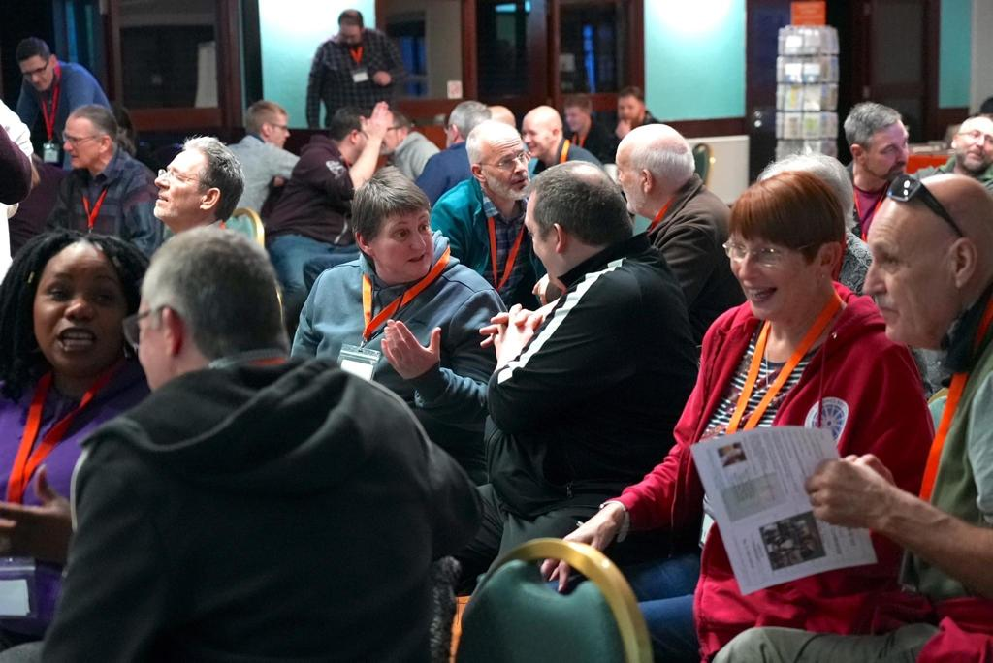
EMBA Ministers’ Conference
I think most would agree that this year’s EMBA Ministers’ Conference was a “wonderful, inspiring, challenging and encouraging time together”.
Our keynote speaker Revd Dr Kate Coleman challenged us to transform leadership from a personal, missional, systemic and global perspective. Revd Sam Dunn and team led us wonderfully in sung worship as we celebrated God at work across the Association. So many people contributed to our time together in special ways, a highlight being Revd Ingrid Shelley sharing stories from her chaplaincy in prisons and hospice care, seeing God’s light pouring through the broken cracks of lives in very dark places.
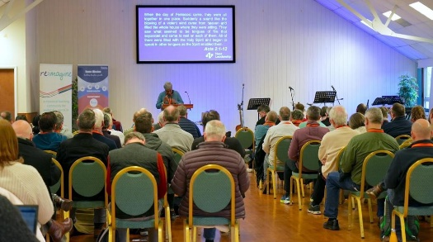
There is a growing sense among ministers that the conference is drawing us closer together and is a significant time for us in our ministries. Let me encourage ministers and churches to invest in these days as a priority for challenging, refreshing, learning and enabling that will have an impact back home in our churches.
Revd Gill Isterling (Conference Coordinator)

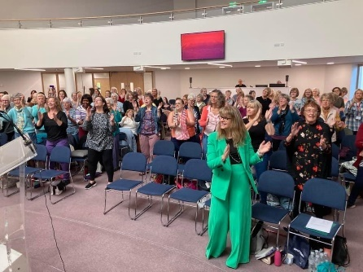
Refresh (Women’s Conference)
We have had two encouraging and inspiring days this year; one in October 2022 at Springwell, Whetstone Baptist church with Helen Roberts speaking. It was a day of encouragement and inspiration, Bible teaching and worship along with prayer and opportunities to respond to God. Around 145 women gathered from churches across the association and beyond.
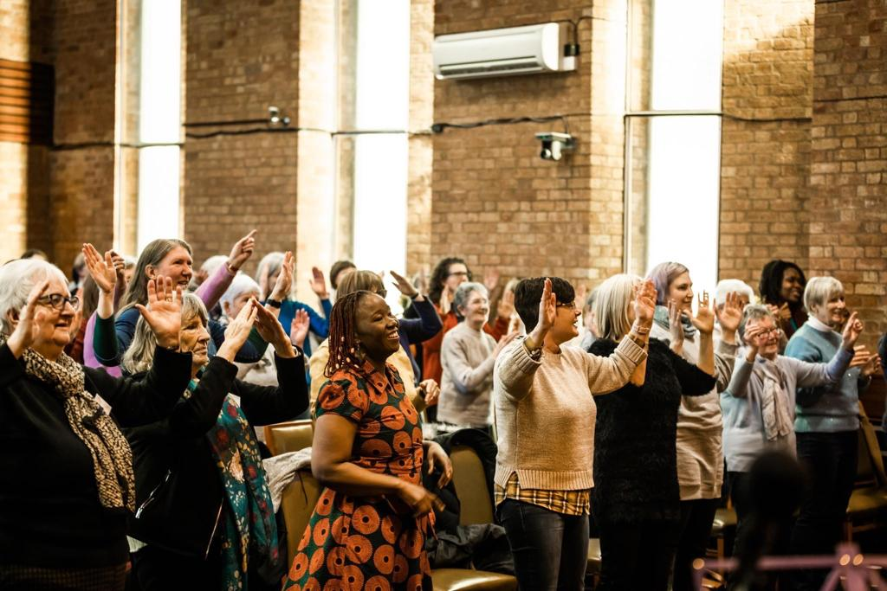
Our second conference was on March 11th 2023 at Mansfield Baptist church; around 130 women gathered from around 35 churches. Rosie Bunker a church leader in Nottingham spoke on the subject of shame and focussed on Genesis 3 and Dianne Tidball spoke on a renewed mind from Romans 12:1-2. There was interactive prayer with salt, honey and owls; a group Bible study on “taking every thought captive to Christ” from Colossians as well as the regular ‘warm up’ and the fantastic Refresh worship leaders, Kate, Rachel and Sarah. Many women received prayer and we were encouraged by how the use of Scripture prophetically spoke movingly to many women and their particular situations.
We are grateful to God for the leading of his Spirit. Many women encountered him and were refreshed in following Jesus and living lives honouring him.

Revd Dianne Tidball (Refresh Coordinator)

EMBA Retired Baptist Ministers’ Network (RBMN)
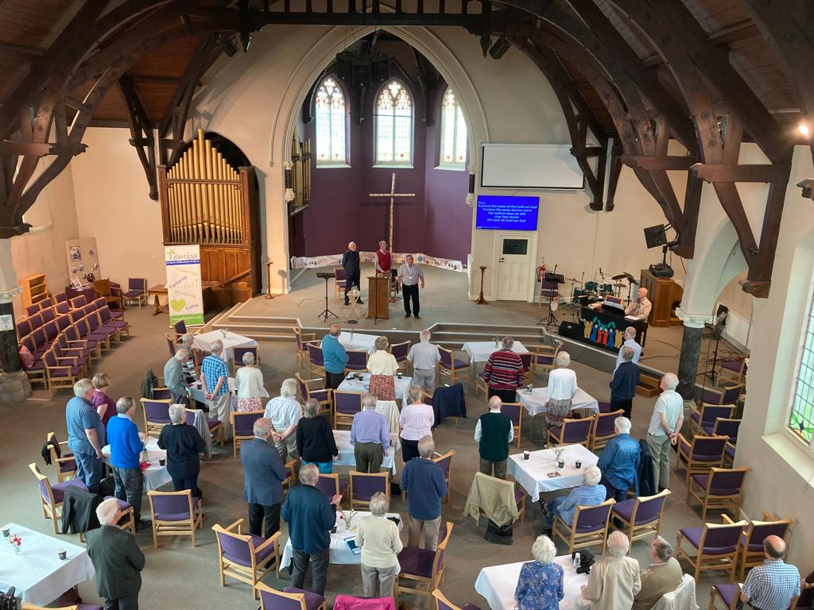
In 2022 four main gatherings took place. In April the then President of The Baptist Union, the Revd Geoff Colmer was to have joined us via ZOOM during Lent to reflect on his Presidential theme - Rhythms of Grace. An unexpected recall to hospital, however, meant that we found ourselves instead listening to Geoff via a YouTube video. His reflections on finding God at unexpected times, and in sometimes unusual places, led to some good discussion in breakout groups, followed by a time of prayer together. In June we held our first post-Covid in person meeting – and what a splendid occasion it was. It was wonderful to welcome back to the EMBA David and Janet Coffey. The Revd Dr David Coffey, was well known to us all, having served as General Secretary of our Baptist Union for fifteen years prior to becoming President of the Baptist World Alliance 2005-2010. Over 40 of us gathered to hear him. His first session, which can be accessed via the EMBA website, was A Pastoral Reading of John 11. After a splendid buffet lunch, kindly provided for us all by the EMBA, David, in his second session, shared some fascinating anecdotes drawn from six decades of ministry. Now in his early 80s, David’s voice and message were as clear and strong - and appreciated - as ever.
In September our RBMN planning group meeting was held - again in person – at the EMBA Offices, with some retired Ministers from across the Region. All of us had agreed to try to develop more local gatherings of Retired Ministers here in the EMBA over the next two years or so. Updates were heard / received from Revd Ron Day (Rutland and Leicestershire), Revd Clive Doubleday (Peterborough), Revd Arderne Gillies (Nottinghamshire 1), Revd Dick Prior (Nottinghamshire 2 ), Revd Nic Hasnip (Lincolnshire), and Revd Jane Webb (Derbyshire). The importance of drawing in only Retired Ministers who want to opt in in to such gatherings was emphasised. Finally in 2022 we continued our pattern of gifting an agreed book, upon request, to Retired Ministers for discussion during our Advent gathering. This year the book was Dane Ortlund’s Surprised by Jesus – Subversive Grace in the Four Gospels. As Ortlund explains: ‘...each of the four gospel accounts in the Bible uniquely gives us a Jesus who turns upside down our intuitive anticipation of who he is and how following him works.’ After an introduction to, and review of, the book we shared our reflections on it in breakout groups before ending our morning gathering in prayer together.
In 2023 three RBMN events are – again - anticipated in addition to the more local meetings. 1) A Lent Gathering – ‘ Lent and Dissent’ - led by Revd Dr Sally Nelson (St Hild’s) on Thursday 30 March 2023, 10-11.45am via Zoom. 2) A Summer Gathering with Revd Prof. Philip McCormack (Principal of Spurgeon’s College) – Tuesday 13 June 2023, 10-3pm, in-person. 3) An Advent Book focus – December 7th 2023 10-11.45am via Zoom.
Around 80 Baptist Ministers have “retired” in the East Midlands. In 2022 it has become clear that a pattern is emerging across the RBMN. Some of us prefer to meet by ZOOM only, some enjoy both ZOOM and in person gatherings, some will engage only very occasionally, and some not at all. It has been good, then, to witness a growing number committing to these gatherings and, it seems, clearly valuing them. It is also pleasing to note that what we are developing here in the EMBA is proving to be such a helpful new model for meaningful engagement between a Regional Association Ministry Team and RBMs. Finally, I wish to reiterate that the Network would not be happening at all without the active affirmation and support of Mark Clay, his PA Becky Nicholls, and the EMBA team. We remain grateful to them all for this.
Revd Michael I Bochenski (EMBA – RBMN Coordinator)

BUEN: Baptist Union Environment Network
The latest IPCC report delivers a ‘final warning’ on the climate crisis, saying ‘act now, or it’s too late’. Tom Rivett-Carnac, a former UN adviser who worked on the 2015 Paris climate agreement, says ‘We need to use all platforms and angles that we can to realise the unique nature of this moment, and the privilege to be here and have the chance to make a difference.’ This is the attitude BUEN is encouraging churches to take.
Over the past year the Midlands hub of BUEN has been working across EMBA, HEBA and nationally to support churches to care for God’s creation. Since its launch in 2021, the BUEN Midlands network has now grown to around 80 people representing over 45 churches in the midlands. From amplifying campaigns like JPIT’s ‘Net Zero in my Neighbourhood’ and Tearfund’s ‘Time to Deliver’, to sharing ideas and expertise between churches, the network has been raising awareness of what churches can practically do to respond to the climate crisis and why it is part of our God-given mission to do so. Fixing solar panels to buildings, leading Climate Sunday services, putting on litter picks, setting up community gardens, partnering with local government and MPs to influence new policies, petitioning and tree planting – these are just some of the actions churches in EMBA have taken.
In July 2022 EMBA led a national Zoom event showcasing the variety of eco-efforts in churches from all parts of the country, with 8 guest speakers from different associations and BMS, and 40 churches represented by over 60 attendees. Topics included community energy generation projects, A Rocha’s ‘Eco Church’ award, BMS’ sustainability work in Peru and putting on a local eco festival.
Look out for BUEN at the 2023 Baptist Assembly where we will be presenting. We have more exciting plans for 2023, and we can also help your church if you are looking for a speaker on creation care or thinking about running an event or church service about climate change. Sign up on the EMBA website for updates from the BUEN Midlands network so you don’t miss out on events, resources or news.

Rachel Third (Coordinator and EMBA Rep for BUEN Midlands)

Welcome to new EMBA ministers
Those in ministry who we have welcomed into the Association over the last year are:
Doug Atherton (Eastwood BC, Notts)
Robert Foster (Belper BC, Derbys)
Jason Griffiths (Grimsby BC, Lincs)
Robert Holmes (Cross Hills BC, Bagworth, Leics)
Natalie Hughes (Thomas Helwys BC, Notts)
Rob McGibbon (Grantham BC, Lincs)
Michael Peat (Loughborough BC, Leics)
Daniel Pollin (Lincoln BC, Lincs)
Karen Smilley (Spalding BC, Lincs)

Welcome to new churches
We are delighted to have welcomed Christ Victory Baptist Church, Nottingham into membership of the Association and Baptist Union.

Ministerial Recognition
Fully Accredited Baptist Minister (FAM)
Having successfully completed their Newly Accredited Minister (NAM) studies the following ministers now transfer to the Fully Accredited Baptist Minister list:
Revd Christopher Brown (Market Harborough BC, Leics)
Revd Leigh Greenwood (Stoneygate BC, Leics)
Revd Susy Insley (Hospital Chaplain)
Revd Simon Robinson (Watnall Road BC, Notts)

National Recognition as a Pastor (NRPa)
Pastor Liz Connelly (Pastor at Barlestone BC, Leicestershire)

Finance review
Last year Home Mission Giving nationally was down over 14% on 2021 following a much smaller decrease the year before.
This decrease means that the Association has had a £31,623 clawback. In the short term, the Association has reserves to draw on; a position that's not sustainable long-term and not all Associations have the luxury of reserves.
For quite some time there has been the general expectation across the Baptist family that churches give 5% of their income towards the work of Home Mission. We know times are difficult and this has led some churches to reduce their giving in this area. However, we would gently encourage Ministers and Churches to review their giving to Home Mission so that we can continue to support them in their mission, can continue to offer grants, fund new pioneering initiatives and offer training and advice.

Making donations
Where possible, if donations could be made by bank transfer or standing order this would be greatly appreciated and aid administrative processes.

To Home Mission
If you wish to send a cheque payment, please make the cheque payable to 'EMBA Home Mission’ and send FAO Jack Liquorish, c/o EMBA Office, West Bridgford Baptist Church, Melton Road, West Bridgford, Nottingham NG2 7NF.

All other donations to EMBA should be sent:
FAO Irene Milburn (EMBA Bookkeeper) c/o EMBA Office, West Bridgford Baptist Church, Melton Road, West Bridgford, Nottingham NG2 7NF.
Please make the cheque payable to 'EMBA General A/C’ and attach a covering note explaining what the payment is for.

EMBA Working Groups

East Midland Baptist Trust Company (EMBTC)
Chris Hanning (Moderator), Tim Jackson (EMBTC Treasurer), Gary Anderson

Grants Group
Ellie Ake, Sam Hackett, Sue Hensby, Graham Watkins

Ministerial Recognition Committee (MRC)
Colin Bowden, Ellie Cockbill, Christine Cook, Gert Glasius, Jon Grant, Chandra Morbey, Richard Nicholls

Ministers’ Conference Planning Group
Gill Isterling (Coordinator), Tom Cox (Treasurer), Rashell Beya, Christopher Brown, Sam Dunn, Sarah Fegredo, Jon Grant

Refresh (Women Conference)
Dianne Tidball (Coordinator), Vivienne Edwards, Sarah Liquorish, Linda Patel

Retired Baptist Ministers’ Network (RBMN) Planning Team
Michael Bochenski (Coordinator), Ron Day, Clive Doubleday, Arderne Gillies, Nic Hasnip, Dick Prior, Jane Webb

Safeguarding Team
Dave Bedford, Clare Blain, Elaine Burrows, Alan Davies, Sarah Fegredo, Sarah Jones, Malcolm Grimley, Kenny Henry, Paul Muir, Helen Parker, Amanda Tasker

And to all who support the work of the Association
THANK YOU

Contacting the Association Team

EMBA Staff Team

Admin Lead and PA to RTL
Mrs Becky Nicholls Tel: 07763 401 793 Email: becky.nicholls@embaptists.org.uk

Admin Assistant
Mrs Gill McNab Tel: 07483 119 627 Email: gill.mcnab@embaptists.org.uk

Regional Ministers
Revd Mark Clay – Regional Team Leader (RTL)
Tel: 07975 863 772 Email: mark.clay@embaptists.org.uk

Revd Dr Nick Ashton
Tel: 07399 660 047 Email: nick.ashton@embaptists.org.uk

Revd Mike Fegredo
Tel: 07972 350 242 Email: mike.fegredo@embaptists.org.uk

Wider EMBA Team
Communications Lead: Mrs Hannah Fleming-Hill
Email: hannahfleminghill@embaptists.org.uk

EMBA Treasurer: Mr Andy Smallridge
Email: andy.smallridge@embaptists.org.uk

Bookkeeper: Ms Irene Milburn
Email: irene.milburn@embaptists.org.uk

EMBTC Treasurer: Mr Tim Jackson
Email: tim.jackson@embaptists.org.uk

Data Protection Officer: Mr Garry Clewlow
Email: garry.clewlow@embaptists.org.uk

Home Mission Administrator: Mr Jack Liquorish
Email: jack.liquorish@embaptists.org.uk

Settlement Administrator: Mrs Julie Lazonby
Email: julie.lazonby@embaptists.org.uk

EMBA Associates
People recognised and endorsed by the Association in offering specific skills and experience to the churches of the EMBA (largely in a voluntary capacity) thereby expanding the capacity of the Regional Team.

Children, Young People and Families (CYF): Revd Sarah Fegredo
Church Development: Revd Graham Dunn
Ministerial Development: Revd Nick Swanson
Pioneering Support: Revd Sue Steer
Spiritual Accompaniment: Revd Stephen Ibbotson
Training: Revd Elaine Burrows and Revd Nick Swanson

