East Midland Baptist Association
Developing a Mission Action Plan (MAP)

INTRODUCTION
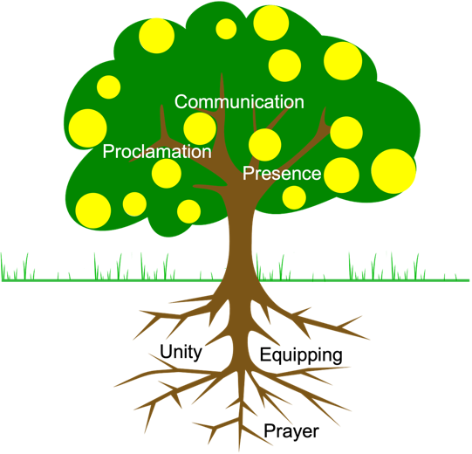
We start with a reminder of the EMBA MAP process. Each of the three phases of the process addresses a question as follows: 1. Where are we now? (the current reality) 2. Where could we be? (the options) 3. Where will we be? (the plan). See the EMBA MAP Introduction for further details.
This document concerns phases 2 and 3 of the process and assumes that the Fruitfulness indicators self-assessment form has been completed and its output prayerfully reflected on. (i.e. phase 1 has been completed). This document uses the idea of Fruitfulness Indicators to show how progress in each of these areas help create the conditions for kingdom fruitfulness.
The image of the tree seeks to show how the different indicators connect to the whole. It offers a picture of a fruitful church. The yellow balls are the kingdom fruit that we hope will grow in due season. The green leaves (proclamation, presence, and effective communication) are the key mission edges where the faith community rubs shoulders with the wider community (they are the most visible aspects of the faith community). The brown trunk and root system remind us of the essential supporting nature of prayer, equipping for ministry and mission, and unity of purpose.
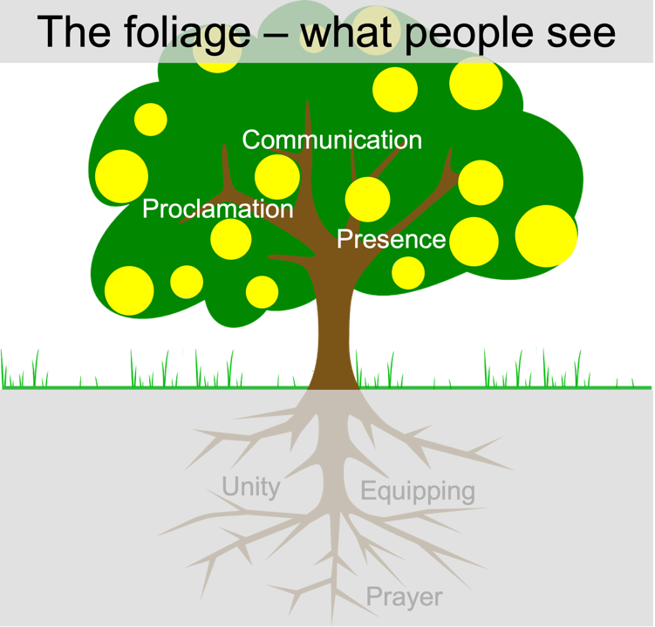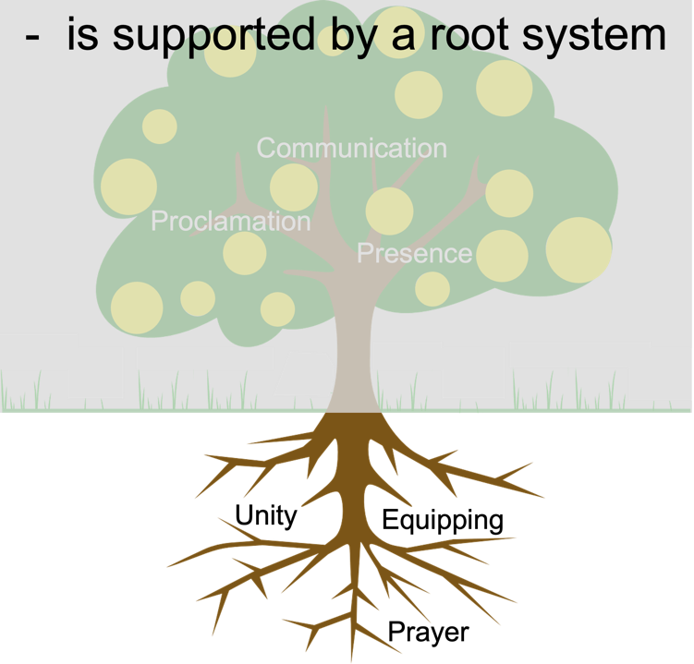
The suggestion is that for a church community to be fruitful careful attention needs to be given to each of these elements. All are needed and important. Whilst hard and fast formulas are misguided, churches are more likely to flourish when the visible indicators (proclamation, presence and communication) are healthy and developing; though for this to happen the core supporting elements of unity of purpose, creative prayer, and focused equipping must also be in place.
HOW TO USE THIS DEVELOPMENT TOOL
Outlined below is a worked example of a Mission Action Plan, followed by a blank template. The blank template should be used twice; in phase 2 to generate & record ideas and possibilities for development; and again in phase 3 to prayerfully refine those ideas and determine plans that should be made. Phases 2 and 3 should take into account any provisional priorities that emerged during phase 1. Churches working with a Mission Accompanier should ensure that their accompanier is fully involved in phase 3. Leadership teams will normally wish to spend a minimum of 2 or 3 sessions working through phases 2 and 3 to allow time for the prayerful incubation of ideas and discerning realistic plans.
Phase 3 seeks to capture plans for two time horizons: 1-2 years and 3-5 years.
Having captured these emphases and plans, one further exercise of discernment is provided in the template section headed “Priority Goals and Actions”. Here, you are asked to state what your priority goals will be in the next 12 months, what actions are necessary to achieve them, who will take responsibility for each action, and the deadline by which it will happen. This step is important as it helps focus the big picture plan on the actions that come next.
At the end of the template you are asked to set a review point when you can measure progress against your plan and make adjustments as necessary. Reviews should then take place at least annually when both the big picture plan and the priority goals for the next 12 months can be updated.

MISSION ACTION PLAN - Little Church on the Heath (Example)
Our Mission Statement
‘Seeking to know God through Jesus and make his love known in our community’
It is intended that this Mission Action Plan will explain our current situation and our longer term aims to fulfil our mission statement.
 | PRESENCE | PROCLAMATION | COMMUNICATION
 | This is where you outline your starting point and describe your current situation/position
WHAT ARE WE PRESENTLY DOING? | - Have a body of people with a wide range of skills and abilities  - Some outreach activities already taking place  - Some people connected into community groups  - We are a friendly people | - Good Churches Together group  - Limited social media and online presence  - Previous experience of running just looking course (didn’t go particularly well) | - Working with other churches  - United by spending time together in prayer and Bible study groups  - Good pastoral care and support  - A willingness to change and move forward
This is where you state the dreams/ideas that you sense God is calling you to in these various areas of mission
– list 3 to 6 ideas under each area
WHAT ARE WE PLANNING TO DO OVER THE NEXT 1-2 YEARS? | HOW CAN WE BLESS THE COMMUNITY?  Be realistic – do a few things well!  - Prayer tree in the church garden.  - Help initiate a ‘village fete’ using contacts (from Messy Church) to establish a group who will explore putting on – an opportunity to work ‘with’ not for people in the community.  - Do a survey to find out what the real needs of this community are? Perhaps, this is one way of going door to door without an agenda  - Do something with the results of the survey and let people know! See if there is a response that the church can get involved in. Perhaps even get the press involved!  - Evaluate what you are already doing. Is it having the desired impact?  - Encourage many to find one thing to commit to in the wider community. | HOW CAN WE SPEAK INTO THIS COMMUNITY?  Be mindful of the Engel scale  - Seek to build confidence in individuals to talk God (their story for one minute) and to dare to practice with someone who isn’t a Christian. Then feedback with one another on how this went and how to improve.  - Try TableTalk for use in café/home/school (neutral ground) – a game that encourages conversation about deeper issues.  - Run a Big Questions 5-week program at a neutral venue. This explored the pre-Alpha questions.  - Alpha Course (or similar) once a year (good food essential).  - Set up small (home) based group to build on Alpha, because going to church can be too big a step for many. | HOW CAN WE COMMUNICATE OUR MESSAGE?  Be clear and authentic  - Clarify what it is you want people to know about you.  - Challenge ourselves by asking whether this message is authentic – true to who you are and aspire to be.  - Find out what people think about your church now  - In any public events consider the language used and how people will understand it  - Similarly, review all current communication channels – notice boards, website, facebook page, bulletin and ask whether they are accessible to outsiders.  - The best communication is personal. Encourage church members to get involved in the community and to create a positive impression of Christ and his church.  - If the church doesn’t have a website, find someone to help you set one up. Keep it simple and up-to-date.
WHEN WILL IT HAPPEN  (timescales) | Survey year 1/Fete year 2/Prayer tree ongoing | Try to achieve all this over a two year period | - Year 1 (first 6 months) – research what people think about your church now and clarify what message you wish to convey.  - Year 1 (second half) – review all current communications and make simple changes in the light of your research.
WHO IS NEEDED TO MAKE THIS HAPPEN? | ? | ? | - Someone with analytical skills who understands a little about communication.
RESOURCES REQUIRED? | People to get involved in fete and some financial resources | Purchase material and training | - A book or web resource that offers guidance on improving communication
SUCCESS  CRITERIA | - Survey done and communicated  - Village fete attracting many people and church being seen positively  - Prayer tree a regular feature  - A map showing where impacting | - Baptisms/faith commitments  - A new group filled with people searching  - A younger age group exploring faith  - A regular pattern of ‘stepping’ stones established | - Research completed honestly  - Clarity about the church’s message (about itself and, by implication, the God it serves)  - Development of a simple website which can be easily maintained.
 | This is where you outline what you might like to be seeking to do in 3 to 5 years time – list 1 to 2 ideas under each area (you are not committed to undertake them, but rather be encouraged to think long-term future plans)
WHERE DO WE WANT TO BE IN 3-5 YEARS TIME? | - Modernised building suitable for use as a community space | - Established nurture and discipleship courses helping new Christians develop and grow in their faith  - Greater online presence | - A consistent, authentic, attractive message is conveyed through all communication channels.  - Church members know that they are ambassadors of Christ and his church and act accordingly.

How will you support this through Prayer, Equipping, and Unity of purpose?

Remember, Prayer, Equipping, and Unity of purpose are essential elements of the root system of a tree. Without them fruit will be limited. Write down focused, creative & practical steps in each area that you intend to take. Please note – this is not a box filling exercise, but a way of setting down some good practices & intentions.

- PRAYER – How can we be a more prayerful church?
- Prayer triplets – aim for these to become a key building block for the spirituality of the church
- Encourage exploration of contemplative prayer – plan occasional day retreats
- Explore how to make the prayer meeting a more accessible environment
- Call a week of focussed prayer and fasting

- EQUIPPING – What training and equipping do our members need?
- Faith pictures from Church Army Course – building confidence to tell our story
- Look into examples of good surveys and come up with our own (a community not ‘Christian’ survey)
- Create a mission team to generate some mission ideas, or dedicate a whole church meeting to the same theme
- Trial TableTalk and Big Questions – treat it as an experiment and review how it goes

- UNITY – How can we develop unity of purpose?
- Remind members what the vision of the church is – if the church doesn’t have a vision statement consider developing one TOGETHER
- Celebrate things that align with the churches purpose – e.g. a successful “Carols in the pub” event (or even a not so successful one!)
- Share life together – eat together regularly, organise occasional events that bring people together, e.g. a church walk
- Involve people in a worthwhile and uplifting project – e.g. to bless a church member in need or to bless the wider community at a point of felt need.
- Organise a season of prayer, bringing people together in a variety of ways – small groups, daily set prayer, all together

Statistics

Summarise below the key statistics you chose to tell the story of the church when completing the Fruitfulness Indicators self-assessment tool.

- In the last 12 months, 2 baptisms, 4 new members, 2 membership leavers (one resignation and one death)
- Conducted 2 funerals (including one high profile community funeral)
- Toddler group averages 30 each week – conversations about spirituality now common.
- Planning consent given for new estate of 200 homes given, building to start in 6 months – how can we welcome new residents?
- Finances remain stable

What statistics are appropriate to measure the success of your MAP?

1-2 years

3-5 years

Priority goals and actions

Goal | Action(s) to achieve the goal | Who will lead? | When will it happen?

MISSIONAL ACTION PLAN for “ ” Baptist Church
Our Mission Statement
‘ ’
It is intended that this Mission Action Plan will explain our current situation and our longer term aims to fulfil our mission statement.
 | PRESENCE | PROCLAMATION | COMMUNICATION
 | This is where you outline your starting point and describe your current situation/position
WHAT ARE WE PRESENTLY DOING?
This is where you state the dreams/ideas that you sense God is calling you to in these various areas of mission
– list 3 to 6 ideas under each area
WHAT ARE WE PLANNING TO DO OVER THE NEXT 1-2 YEARS? | HOW CAN WE BLESS THE COMMUNITY?  Be realistic – do a few things well! | HOW CAN WE SPEAK INTO THIS COMMUNITY?  Be mindful of the Engel scale. | HOW CAN WE COMMUNICATE OUR MESSAGE?  Be clear and authentic.
WHEN WILL IT HAPPEN
(timescales)
WHO IS NEEDED TO MAKE THIS HAPPEN?
RESOURCES REQUIRED?
SUCCESS
CRITERIA
 | This is where you outline what you might like to be seeking to do in 3 to 5 years time – list 1 to 2 ideas under each area (you are not committed to undertake them, but rather be encouraged to think long-term future plans)
WHERE DO WE WANT TO BE IN 3-5 YEARS TIME?

How will you support this through Prayer, Equipping, and Unity of purpose?

Remember, Prayer, Equipping, and Communication are essential as the root system of a tree. Without them fruit will be hard to find. Write down focused, creative & practical steps in each area that you intend to take. Please note – this is not a box filling exercise, but a way of setting down some good practices & intentions.

- PRAYER – How can we be a more prayerful church?

- EQUIPPING – How can we communicate better?

3. UNITY – How can we develop unity of purpose?

Statistics

Summarise below the key statistics you chose to tell the story of the church when completing the Fruitfulness Indicators self-assessment tool.

What statistics are appropriate to measure the success of your MAP in the next ….

1-2 years

3-5 years

Priority goals and actions

Goal | Action(s) to achieve the goal | Who will lead? | When will it happen?

When will we review the plan?

