## SAFEGUARDING INCIDENT FORM

*This form should be completed by the Designated Person for Safeguarding*

|  |  |
| --- | --- |
|  |  |
| **Name of church / organisation** |  |
| **Contact details of church / organisation** |  |
|  |  |
| **Name of Designated Person for Safeguarding (DPS)** |  |
|  |  |
| **Contact details of Designated Person for Safeguarding** |  |
|  |  |
| **Name of concerned person or to whom disclosure was given** |  |
|  |  |
| **Contact details of concerned person or whom disclosure was given** |  |

**INDIVIDUAL OF CONCERN - CONTACT DETAILS**

|  |  |
| --- | --- |
| Name |  |
| Date of birth |  |
| Address |  |
| Phone number / Email address |  |

**THE INCIDENT**

What happened? (Nature of concern / disclosure made - use the person’s own words if known

When did it happen? (date, time)

Where did it happen? (specific location)

Who was allegedly involved and in what way? (includes witnesses)

ANY ACTION THAT HAS BEEN TAKEN

|  |  |  |  |
| --- | --- | --- | --- |
| Yes |  | No |  |

Have the carers or parents / guardians been informed? (Please tick)

If so, when and by whom?

|  |  |  |  |
| --- | --- | --- | --- |
| Yes |  | No |  |

Have the statutory authorities been informed?

If so, please complete the table:

*Example:*

|  |  |  |  |  |  |
| --- | --- | --- | --- | --- | --- |
| Authority | Police |  |  |  |  |
| Name | Bobby |  |  |  |  |
| Position | Child abuse officer |  |  |  |  |
| Email contact | bobby@police.com |  |  |  |  |
| Phone contact | 077999 |  |  |  |  |
| Contacted by | Minister |  |  |  |  |
| Date & time of contact | 1.30pm  1/4/15 |  |  |  |  |

|  |  |  |  |
| --- | --- | --- | --- |
| Yes |  | No |  |

Has the Local Association been informed?

*(Please do so if the statutory authorities are involved)*

If so, when and by whom?

Any other action taken:

FUTURE ACTION TO BE TAKEN

What action needs to be taken?

Who is responsible for this?

SIGNATURES

|  |  |  |  |
| --- | --- | --- | --- |
| Signature of Designated Safeguarding Person |  | Signature of minister, or Church Safeguarding Team member |  |
| Date & time |  | Date & time |  |

**BODY MAP**

Name of Individual of Concern_______________________________________________________

Name of person completing this form____________________________­­­___________________

These diagrams are designed for the recording of any observable bodily injuries that may appear on the person. Where bruises, burns, cuts, or other injuries occur, shade and label them clearly on the diagram. **Remember it’s not your job to investigate or to decide if an injury or mark is non-accidental. Listen, observe and pass it on.**

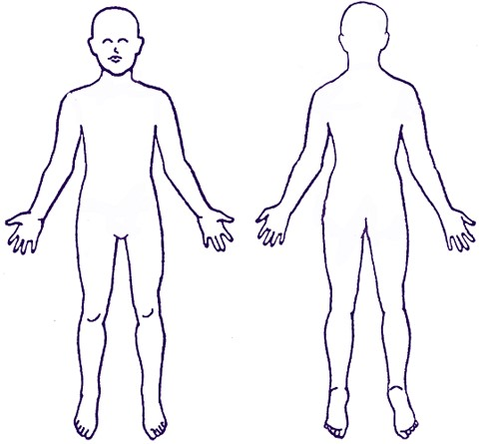

Front Back

Signature _________________________________________________

Date and time ____________________________________________

For more information:

Please see [www.baptist.org.uk](http://www.baptist.org.uk) for more information about safeguarding in Baptist churches, including a range of specialist guides and a library of free downloadable resources.

**BUGB Excellence in Safeguarding training for your church:**

Information and booking arrangements for the BUGB Levels 2 and Level 3 Excellence in Safeguarding training can be made through your local Baptist association team. Please see their website for details of nearby courses or the opportunity to host safeguarding training at your church.

**In an emergency:**

If you find yourself facing an emergency situation, where you believe that someone attending your church is being harmed or is at imminent risk of harm, please ring the police on 999 and ask to speak to an officer in the child or adult protection teams. Always keep records and let your DPS know that you have made this call.



**This policy has been produced for use in Baptist churches in England and Wales.**

**Policy last updated: November 2017**

Safeguarding Team, Baptist Union of Great Britain, Baptist House, PO Box 44, 129 Broadway, Didcot OX11 8RT

Tel: 01235 517700   Email: [safeguarding@baptist.org.uk](mailto:safeguarding@baptist.org.uk)   Website: [www.baptist.org.uk](http://www.baptist.org.uk)

BUGB operates as a CIO with registered charity number 1181392