EMBA Safeguarding Policy and Procedures
POLICY STATEMENT
The East Midland Baptist Association, its leaders and trustees, have oversight of member churches within their region. Although they do not have direct responsibility for safeguarding practice within the churches, they have a support and challenge role, seeking to train, equip and support those with oversight of safeguarding. Every church is expected to have their own Safeguarding Policy and Procedures reflecting the needs of their own congregation. The East Midland Baptist Association strongly recommends that this is based on the Baptist Union of Great Britain Model Safeguarding Policy and Procedures.
Our Vision
The vision statement of the East Midland Baptist Association is to serve East Midlands Baptists in Mission, through growing healthy churches, and we do this by:
- Inspiring
- Equipping
- Caring
- Pioneering
- Partnering

In fulfilling this vision, we will:
- Have named Association Safeguarding Contacts with suitable training and experience to support churches with safeguarding matters
- Have a named safeguarding trustee responsible, along with the Association Safeguarding Contacts, for promoting safeguarding practice across the life of the Association
- Promote Excellence in Safeguarding within the churches of the Association
- Offer support and advice to churches with safeguarding concerns or incidents
- Provide Excellence in Safeguarding training (Level 2 and 3) in line with the recommendations of the Baptist Union of Great Britain

OUR SAFEGUARDING RESPONSIBILITIES
The Association recognises its responsibilities in safeguarding all children, young people and adults at risk associated with it, both directly and by supporting member churches.
We commit ourselves to the nurturing, protection and safeguarding of all those in our church communities, especially children, young people and adults at risk. In pursuit of this we commit ourselves to this policy and the development of sound procedures to implement our policy well.
Prevention and Reporting of Abuse
It is the duty of every member of the regional association team, including trustees to help prevent the abuse of children, young people and adults at risk and to respond to concerns about the well-being of those within our churches. Any abuse disclosed, discovered or suspected will be reported in accordance with our procedures. We will also support our churches to enable them to respond to

concerns about the well-being of children, young people and adults at risk in line with our procedures.
Safe Recruitment, Support and Supervision of Workers
The Association will exercise proper care in the selection and appointment of all workers, particularly those in a position of trust or working directly with children, young people or adults at risk. All workers will be provided with appropriate training, support and supervision to promote the safeguarding of children, young people and adults at risk.
Supporting Churches
The Association has named persons responsible for supporting churches managing safeguarding concerns (the Association Safeguarding Contacts). They have completed Level 2 and 3 in Excellence in Safeguarding and understand the procedures for escalating safeguarding concerns. Where they are unsure about the best course of action they will work with the National Safeguarding Team to ensure that the situation is managed well and those at risk are properly safeguarded.
Promote Best Safeguarding Practice
All Regional Association staff, trustees and volunteers are responsible for promoting best safeguarding practice amongst the churches they support. This includes seeking support from the Association Safeguarding Contacts when necessary and following the advice that has been given.
Provide Training
The Regional Association will facilitate safeguarding training for churches in our area using the Baptist Union Level 2 and 3 Excellence in Safeguarding material. We will ensure that we have knowledgeable and experienced trainers to facilitate the course who have completed the BUGB Train the Trainer course for each level. The Association will ensure that Level 2 and 3 safeguarding training is available to churches throughout the Region and widely promoted by all regional team members.
Working with national and statutory bodies
To ensure that children, young people and adults at risk within our churches are properly safeguarded, we will work closely with the Baptist Union of Great Britain National Safeguarding Team, statutory authorities, other denominations and uniformed organisations, sharing information where necessary.
Part of this commitment to working together to safeguard children, young people and adults at risk will include the Regional Team Leader (RTL) ensuring that someone on behalf of the Association, will participate in the work of the National Safeguarding Contacts Group (NSCG), which serves as a coordinating body for improvements in safeguarding policy and practice.

SAFEGUARDING CONTACT POINTS WITHIN THE ASSOCIATION
All EMBA churches should have read and understood the ‘EMBA Safeguarding Procedure for Churches’ (Appendix B) which details the process to be followed when a safeguarding matter arises. A copy of this procedure should be displayed in a prominent location within your church.
Association Safeguarding Contacts: EMBA Safeguarding Lead (Kenny Henry), EMBA Safeguarding Adviser (Alan Davies) together with EMBA Regional Ministers (Mark Clay, Mike Fegredo and Nick Ashton).

They will support other regional team members and churches, providing advice and guidance on how to manage safeguarding concerns. This includes supporting churches to put Safeguarding Contracts in place, assisting with safeguarding risk assessments and promoting excellence in safeguarding in all Baptist churches in their regional area.

Contact Details:

Kenny Henry 07498 189 205 kenny.henry@embaptists.org.uk
Alan Davies 07963 675 951 alan.davies@embaptists.org.uk
Mark Clay 07975 863 772 mark.clay@embaptists.org.uk
Mike Fegredo 07972 350 242 mike.fegredo@embaptists.org.uk
Nick Ashton 07399 660 047 nick.ashton@embaptists.org.uk

Association Safeguarding Trustee: Revd Mark Clay (RTL - Regional Team Leader)

They will raise the profile of safeguarding amongst the trustees of the Association and oversee the implementation of the safeguarding policy and procedures on behalf of the trustees.

Contact Details:

Revd Mark Clay 07975 863 772 mark.clay@embaptists.org.uk

PROCEDURES FOR MANAGING SAFEGUARDING CONCERNS AND ALLEGATIONS
The Regional Association Safeguarding Contacts are responsible for ensuring that churches within the Association have access to support and guidance when managing safeguarding issues within their congregation. In addition, the role of an Association Safeguarding Contact is to both support and challenge church leaders where there are concerns about their approach to safeguarding, working with them to attain best safeguarding practice.
There may be occasions when the Association will take the lead in investigating a situation and these will be set out within these procedures. The Association Safeguarding Contacts will seek additional support and advice from the Baptist Union of Great Britain Safeguarding Team and other professionals when necessary. They will maintain a record of all concerns brought to their attention using a Case Record Sheet (Appendix C) and a Case Spreadsheet (Appendix D). All information collected and processed in this way will be held for at least 75 years in line with the BUGB Guide to Safeguarding Record Keeping.

Safeguarding concerns raised about a member of staff or a volunteer working directly for the Regional Association
Regional Ministers
In the case of a Regional Minister the procedures below relating to BUGB Accredited Ministers will be followed.
Other staff, trustees and volunteers
If a safeguarding concern is raised about a member of staff, a volunteer or trustee working directly for the Regional Association then one of the Association Safeguarding Contacts will contact statutory services for advice on next steps, as well as seeking advice from the National Safeguarding Team. If the concern relates to a child or young person, the Local Area Designated Officer (LADO) will be contacted in the first instance. If the concern relates to an adult at risk then the Adult Safeguarding Team will be contacted. In both cases if there is a concern that criminal offences have or may have been committed the Police will be contacted in the first instance.

Safeguarding concerns raised about a BUGB Accredited Minister/Worker
When a member of the Regional Team is advised of a safeguarding concern involving an Accredited Baptist Minister they will contact the BUGB Safeguarding Team or one of the BUGB Ministries Team Co-Leaders within 24 hours, passing over all information they have received about the case.
The BUGB Safeguarding Team and Ministries Team Co-Leaders will agree a strategy for investigation, this will include decisions about who will make the referral to statutory agencies, whether suspension is required and when the person of concern can be informed of the issues that have been raised.
The Regional Minister will work with the national specialist teams (Safeguarding and Ministries) to ensure that information is shared in a timely manner to enable the investigation to progress. They will be led by the national team and will not disclose information to the person of concern or a third party without their agreement.
Pastoral Support
The Regional Association will offer pastoral support to the person of concern. This will not be provided by the Association Safeguarding Contact dealing with the allegation, but by another member of the Regional Team or an experienced minister from another church within the Association.

Safeguarding concerns raised about a Regionally Recognised Pastor/Worker
When a member of the Regional team is advised of a safeguarding concern involving someone who is Regionally recognised, the responsibility for investigating lies with the Association Safeguarding Contacts, with support from the National Safeguarding Team if needed. On occasions the Association may decide to subcontract the investigation to a third party such as 31:8 or an independent safeguarding consultant. However, the Association remains responsible for ensuring that the outcome of the investigation is acted upon and the advice given is followed.

The Regional Association Safeguarding Contact dealing with the allegation, will work closely with the statutory authorities. If the concern related to a child or young person the Local Area Designated Officer (LADO) will be contacted in the first instance. If the concern relates to an adult at risk then the Adult Safeguarding Team will be contacted. In both cases if there is a concern that criminal offences have or may have been committed the Police will be contacted in the first instance.

Safeguarding concerns raised about an Unaccredited Minister or Pastor
If safeguarding concerns are raised about an unaccredited minister or pastor these should be managed by the trustees of the church in the first instance. The Association’s role in this situation will be to support the church with the investigation. They will involve the National Safeguarding Team if necessary.
Although the Association will offer support, the church will need to take the lead in contacting statutory services. If the concern related to a child or young person the Local Area Designated Officer (LADO) will be contacted in the first instance. If the concern relates to an adult at risk then the Adult Safeguarding Team will be contacted. In both cases if there is a concern that criminal offences have or may have been committed the Police need to be contacted by the church in the first instance.
The Regional Association will offer pastoral support to the person of concern. This will not be provided by the Association Safeguarding Contact dealing with the allegation, but by another member of the Regional Team or an experienced minister from another church within the Association.

Safeguarding concerns raised by a church about the behaviour or well-being of someone who attends the church.
The Association recognises that at times churches need additional support and advice when they have concerns about someone within their care. One of the Association Safeguarding Contacts, or appointed Safeguarding Officers will offer this support and work with the church Designated Person for Safeguarding, consulting with the National Safeguarding Team when necessary. As with unaccredited ministers, the church will take the lead in contacting statutory agencies and undertaking the investigation.
To ensure that the correct advice is given to the church the Association Safeguarding Contact dealing with the concern, will check whether the individual is in a position of leadership or trust within the church. If they are, the church will be asked to contact the LADO or Adult Safeguarding Team to seek their advice before the Association issues further advice.
Safeguarding Contracts
A Safeguarding Contract should be put in place by a church when they are aware that someone is either under investigations for or has convictions for offences against children or adults at risk. The Association will work with the church to ensure that the situation is risk assessed and an appropriate Safeguarding Contract is put in place and the final agreement is robust and in line with the recommendations made by the National Safeguarding Team. The Association will hold a copy of the contract and work with the church to ensure that it is regularly reviewed. One of the Association Safeguarding Contacts will take an active role in facilitating contract meetings between the church and the subject of the contract. This is in line with the guidelines published by the National Safeguarding Team in the guide Safeguarding Contracts: Frequently Asked Questions, which is downloadable from the BUGB website.
If a church is reluctant to follow the safeguarding advice given by the Regional Association, then the Regional Minister with pastoral oversight of that church, will consult with the National Safeguarding Team and a decision made together about the best way to ensure effective safeguards are in place within the church.
Pastoral Care in safeguarding situations
When safeguarding situations occur within a church all those involved will inevitably need additional support and care. This includes the person making an allegation and the person subject to it. The Association will support the church in identifying people who can take on this pastoral role and on occasions may be able to seek support from a different church if they consider that this would be the most appropriate way forward.
DBS CHECKS
The Regional Association will initiate all DBS checks for Accredited Ministers and Regionally Recognised Ministers / Pastors using the Baptist Union account with DDC. Any blemished disclosures will be assessed by the National Safeguarding Team and recommendations will be passed to the Ministries Team in relation to BU Accredited Ministers and Nationally Recognised leaders. When the disclosure relates to a Regionally Recognised Minister the outcome of the risk assessment will be shared with the Regional Team Leader (RTL) in the first instance.
DBS checks for Unaccredited Ministers are the responsibility of the local church. The Association has no legal right to know the information included in the check. However, the Association will request from the church the date and number of the DBS check and this will be recorded on the Dynamo database. This ensures consistency with the recording of information about ministers regardless of their accreditation status.
When an Unaccredited Minister has a blemished disclosure, the National Safeguarding Team will share any recommendations from the risk assessment directly with the church in the first instance. If they consider that the church needs support in implementing the recommendations from the risk assessment, then the Association will be advised of the situation.
The Association will request the date and number of the DBS check for an Unaccredited Minister of a non-BUGB, EMBA church. Where a blemished disclosure is reported, the Association will seek advice from the National Safeguarding Team and offer support to the church in assessing the risks involved and in implementing any recommendations made.

TRAINING
The Association will provide a timetable for safeguarding training throughout the region, using the BUGB Excellence in Safeguarding Level 2 and Level 3 material, and will promote the courses to churches in their area.

The Association will work with the National Safeguarding Team to identify and train specialist Excellence in Safeguarding trainers with a high standard of safeguarding knowledge and experience.
All Association trustees, regional ministers, youth and children's specialists and other pastoral staff will complete Excellence in Safeguarding Level 2 and 3 and work in accordance with the principles and teaching they have received through the courses.
SUPPORTING AND EQUIPPING THE DESIGNATED PERSON FOR SAFEGUARDING (DPS) WITHIN MEMBER CHURCHES
It is the responsibility of each church to appoint at least one Designated Person for Safeguarding for their church. The Association will seek to offer specific support to the Designated Person for Safeguarding, particularly when safeguarding concerns arise.
IMPLEMENTATION AND REVIEW OF POLICY AND PROCEDURES
These Safeguarding Policy and Procedures will be agreed by the Association Trustees and distributed amongst all members of the Association staff team, Association safeguarding team and to all EMBA Trainers. It will be reviewed on a 3-yearly basis.

DATE POLICY AGREED: EMBA Directors’ Meeting on 28 February 2023
DATE OF NEXT REVIEW: February 2026
Updated: October 2023
APPENDIX A
THE ROLE OF AN ASSOCIATION SAFEGUARDING CONTACT (ASC)

- To provide a first point of contact for advice when a safeguarding issue arises in a church
- To offer advice and guidance on the application of safeguarding policy and procedures at church level, including the involvement of statutory authorities as appropriate
- To offer on-going support to churches managing a safeguarding issue
- To challenge church leaders and trustees when good safeguarding practice is not in place
- To work collaboratively with the National Safeguarding Team to support our churches with complex safeguarding matters
- To promote excellence in safeguarding amongst Association colleagues and member churches
- To work collaboratively with other ASCs as part of the National Safeguarding Contacts Group and contribute to the development, implementation and review of safeguarding policies, procedures and projects at a national level.

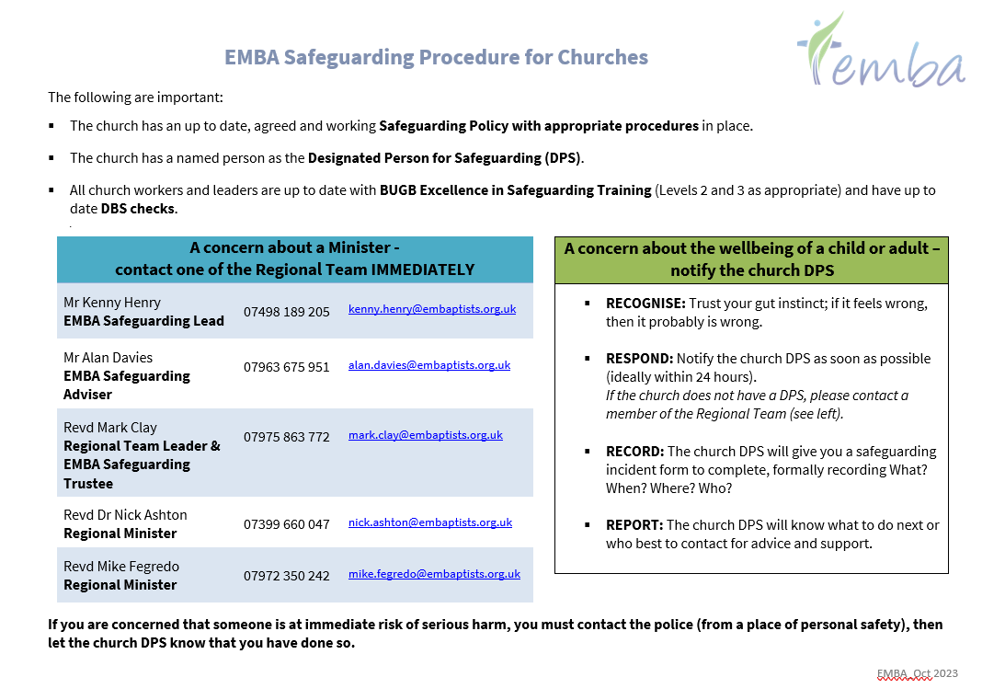
APPENDIX B

APPENDIX C
STRICTLY CONFIDENTIAL
Safeguarding Case Contact Sheet
Referrer Name
Referrer Position

Referrer Phone No. |  |  | Email:
Church Name
Association

Person of Concern Details | Name |  |  | DOB
 | Address | Phone No. |  | Email
Alleged Victim / Victim Details | Name |  |  | DOB
 | Address | Phone No. |  | Email
Situation
Action taken
Next steps needed
People to inform
Name
Date
Date for File Destruction

Additional Contact Notes
Date | Details of Additional Contact / Action taken | Initials

APPENDIX D
ASSOCIATION SAFEGUARDING CASE SPREADSHEET - SAMPLE
